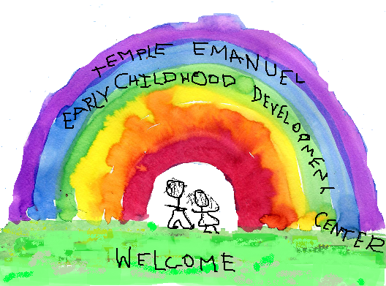
Temple Emanuel
Early Childhood Development Center
Registration for our 2016-17 programs
Begins on January 19, 2016!

Did you know that ECDC offers?
- Programs for children ages one to six
- An outstanding teacher-child ratio of 1 to 5
- Art, Music, Drama and Cooking
- Flexible programming with full-day options
- A warm and supportive environment
- A climate that fosters love of learning

Priority placement is available for members of Temple Emanuel and currently enrolled ECDC families who register by February 12, 2016. The registration fee of $60 in non-refundable.

Please contact Iris Harlan, ECDC Director at iharlan@templeemanuelpgh.org to schedule a visit.

Registration and Forms
Registration Form
Please use the form below to indicate your interest in our program. The ECDC Director will contact you to schedule a visit.
Forms:
- ECDC Registration Form 2016
- Intake Form 2016
- Child Health Report
- Emergency Contact Form

